CS 521 Assignment4

Hanqing Guo

In this assignment, I substracted 20 games for each players, to calculate their average performance includes damage, damageToken, Death, Kill, Money and win Rate. I summarized 139 players average performance for their latest 20 games. And save this data to clean format. Then use pandas to analyze them.

The data in Pandas DateFrame like this:

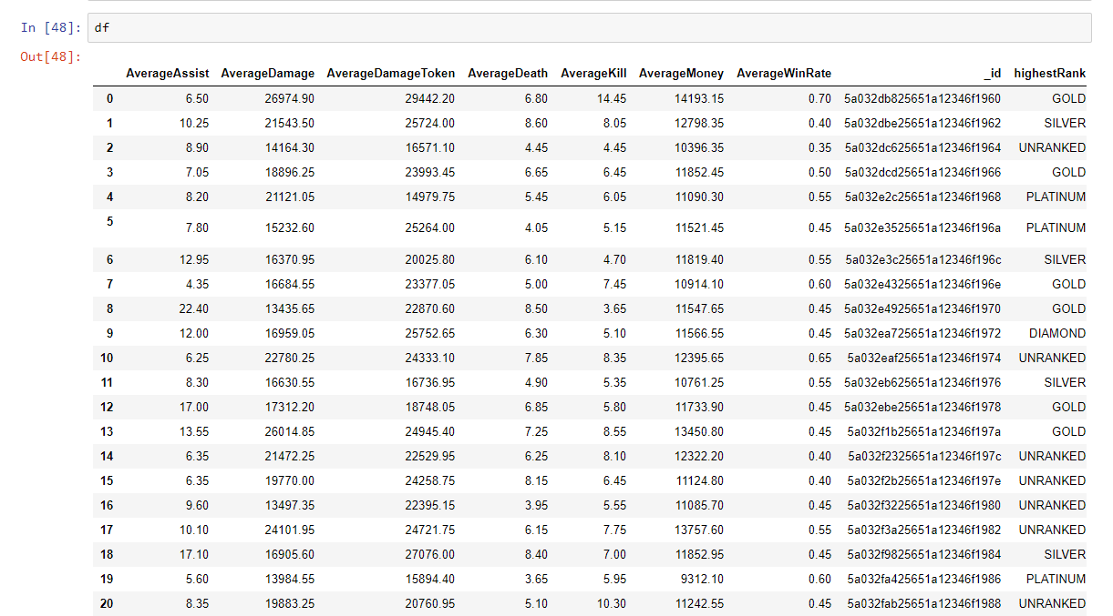

1. Total Counts

Total Counts for winrate:

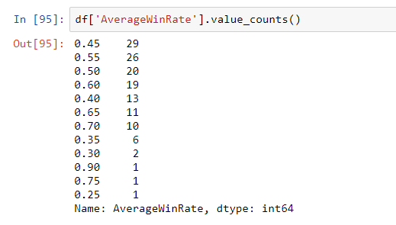

Total Counts for highestRank:

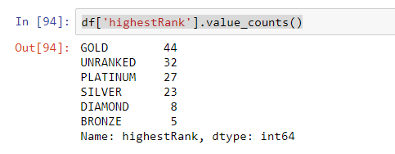

1. Number of Missing values

No missing values.

1. Max

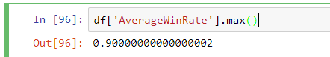

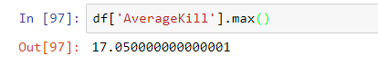

1. Min

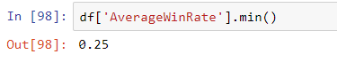

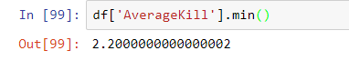

1. Mean

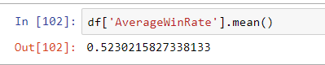

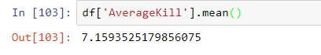

1. Median

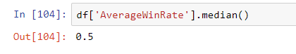

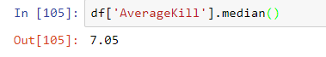

1. Q1 AND Q3

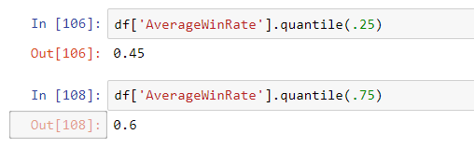

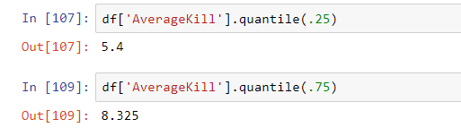

1. Std DEV

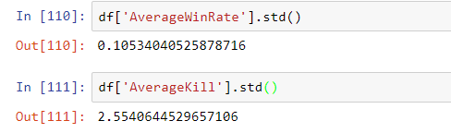

1. Outliers

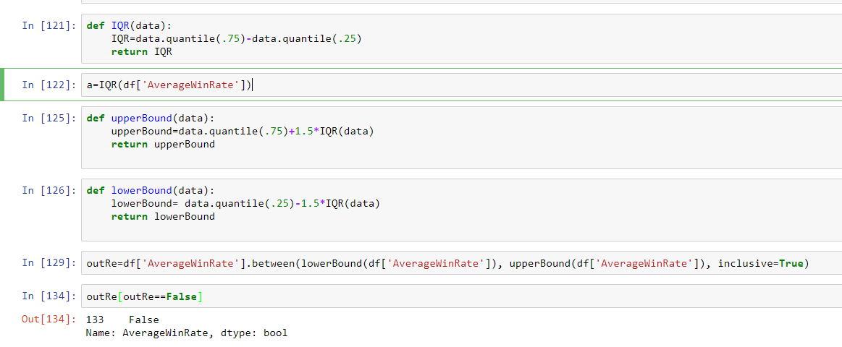

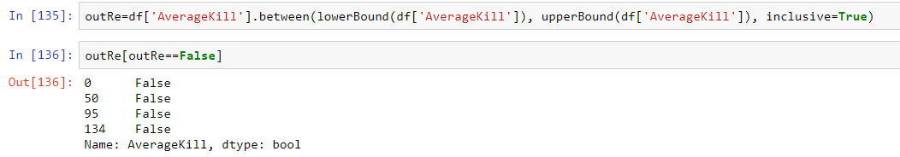

1. Box plot

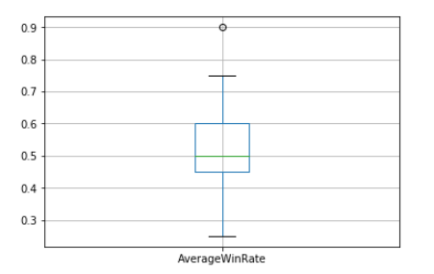

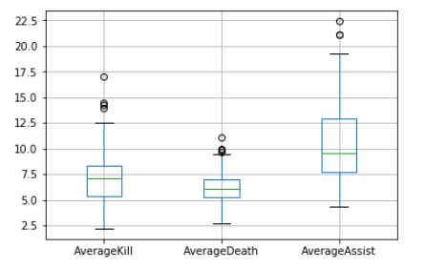

1. Histogram

WinRate:

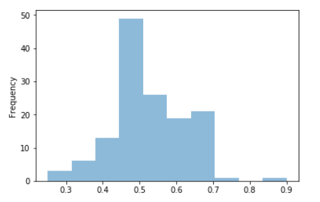

AverageKill:

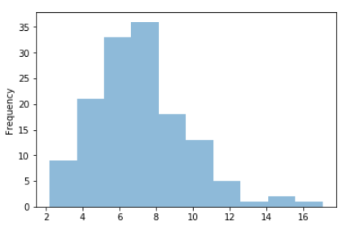

1. Found:
2. Most player still in the medium rank level. Gold rank.

Interesting thing is:

The lowest rank level Bronze is less than Diamond!!

That’s say new players is so small.

As can be seen from the Total Counts for highestRank.

1. The win rate of these players has only one outliers, that means in general, even though some outliers exists in AverageKill and AverageAssist, but the game is still balance, the low level outliers has limited effect on high level win Rate result.
2. The AverageKill for those players distribution is not fit Normal Distribution. It more like a Poisson Distribution. That means, the small portion best players can dominate the game, while larger portion players Kills amount below the average Kills.
3. The average WinRate of these players is 0.52, and the distribution of winrate shows the game is still balance, and these player has higher winrate because more of them located in the right of 0.5.